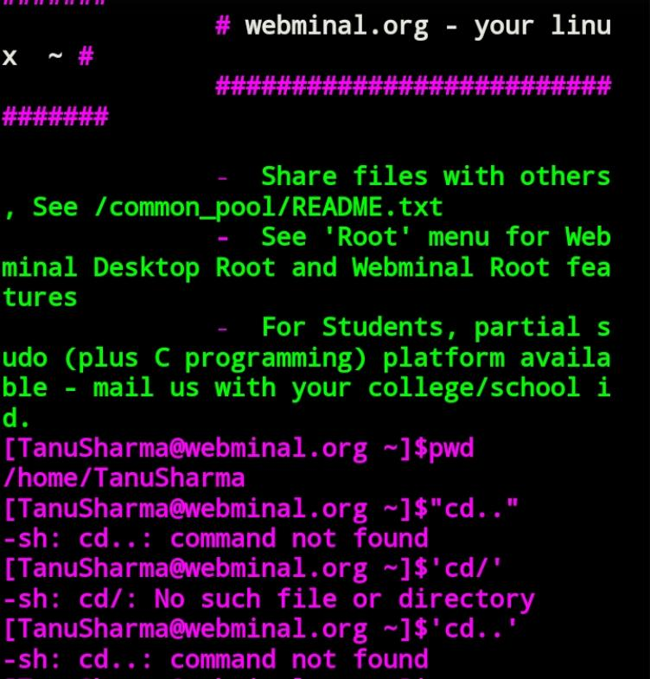
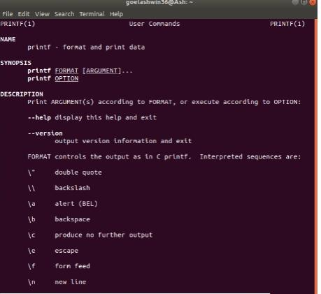
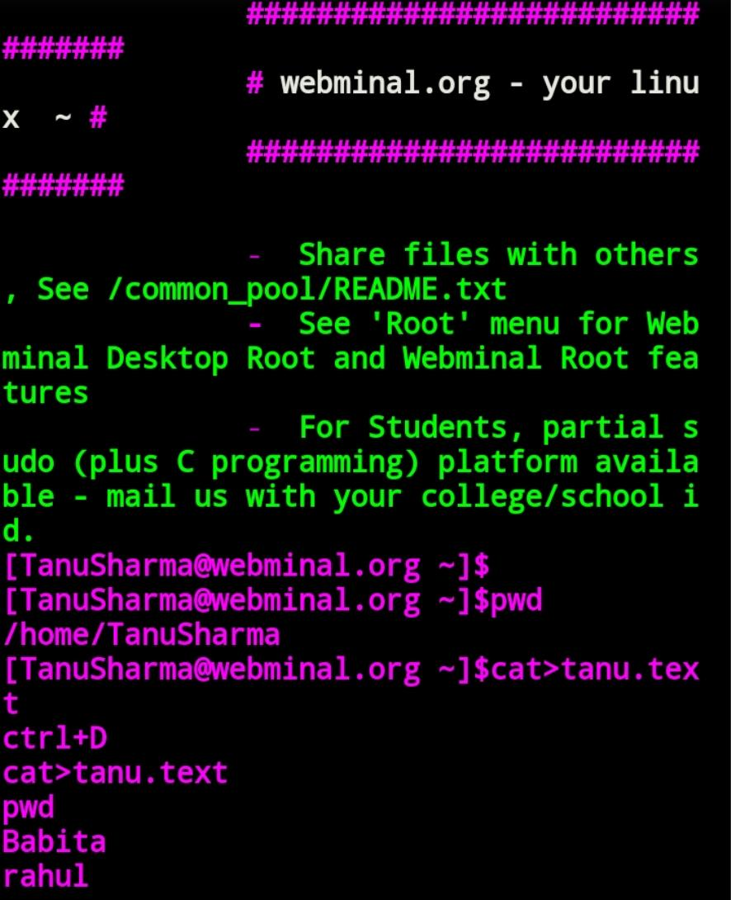
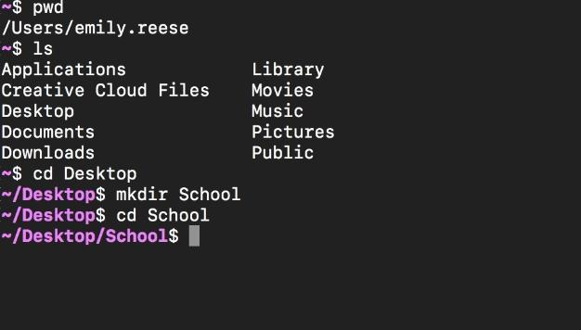
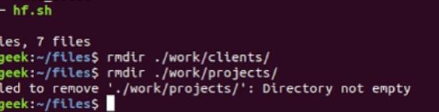
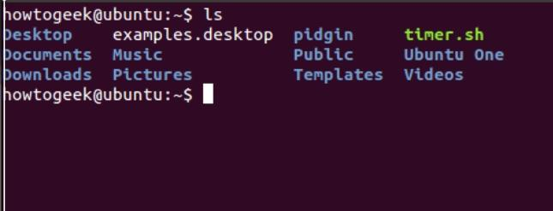
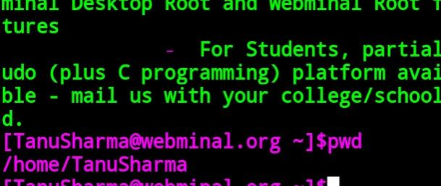
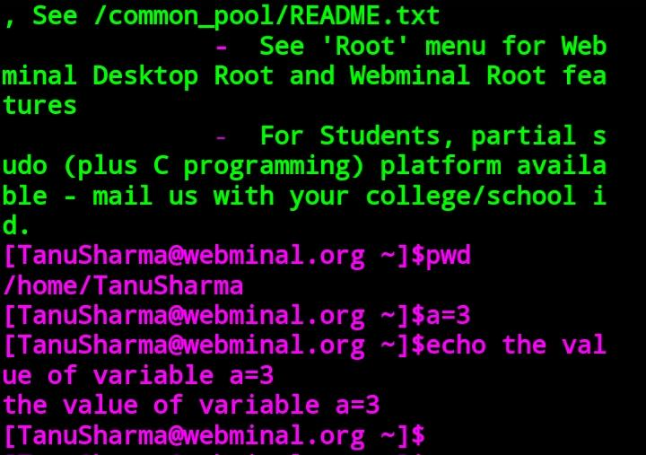
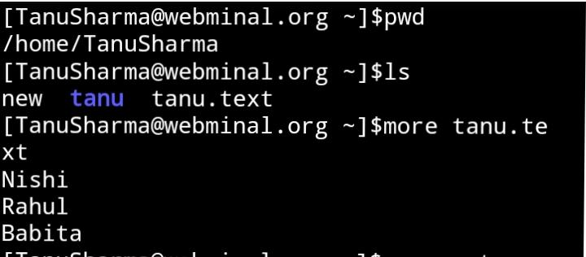
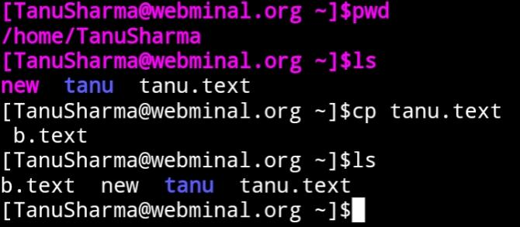
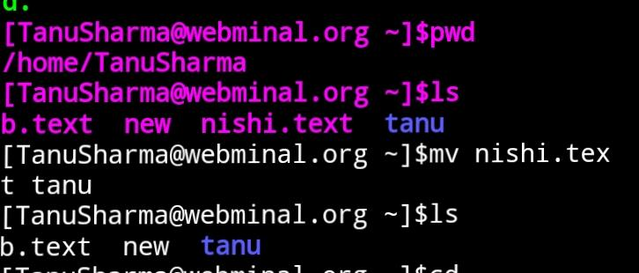
LINUX

(Practical File) .

- SUBMITTED BY :- Tanu Sharma.
- SUBMITTED TO :- Ms. Birpal.
- COURSE :- Btech.CSE.
- ROLL NO. :- GU-2018-3283.
- SEMESTER :- Fifth.

PRACTICAL :- 1

BASIC COMMANDS ON LINUX.

- Cd command :- It is used to change the current directory in linux.It is similar to CD and CHDIR commands in MS-DOS.
Syntax :- cd [option] [directory].
- man command :- It is used to display the user manual from any command that we can run on the terminal.
Syntax :- $ man [OPTION]……[COMMAND NAME]…
- cat command :- It reads data from files and give their content as output.It helps to create,view and concatenate files.
Syntax :- cat>tanu.text(for creating a file)

- make directory :- The mkdir (make directory) command is used to make a new directory,the command is often abbreviated to md.
Syntax :- mkdir foldername.
- remove directory :- To remove an empty directory, use the rmdir command. If the directory still contains files or subdirectories, the rmdir command does not remove the directory
Syntax :- rmdir.

ls command :- ls command in Linux/Unix
ls is a Linux shell command that lists direct
  - ory contents of files and directories.
Syntax :- $ ls [options] [file|dir]

- pwd command :- pwd stands for Print Working Directory. It prints the path of the working directory, starting from the root. Syntax :- pwd

- echocommand :- It is used to display line of text/string that are passed as an argument.
Syntax :- echo [string]

- more command :- It is used to view the text files in the command prompt, displaying one screen at a time in case the file is large (For example log files). The more command also allows the user do scroll up and down through the page.

Syntax :- more [-options] [-num] [+/pattern] [+linenum] [file_name]
- [-options]: any option that you want to use in order to change the way the file is displayed. Choose any one from the followings: (-d, -l, -f, -p, -c, -s, -u)
- [-num]: type the number of lines that you want to display per screen.
- [+/pattern]: replace the pattern with any string that you want to find in the text file.
- [+linenum]: use the line number from where you want to start displaying the text content.
- [file_name]: name of the file containing the text that you want to display on the screen.

- Cp command :- cp stands for copy.It os used to copy files or group of files or directory. It creats an exact image of a file on a disk with different filename.

- mv command :- mv stands for move command.It is used to move files through the command line or to rename the file.For example- If we want to rename the file “text” to “new”,we can use “mv text new”.It takes two arguments, just like the cp command.
Syntax :- mv[option] source destination:-

- env command :- env is used to either print environment variables. It is also used to run a utility or command in a custom environment. It is often used by shell scripts to launch the correct interpreter. In this usage, the environment is typically not changed.
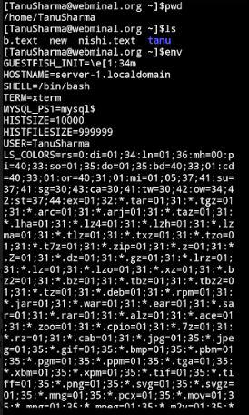
13. du command :- It is disc utilization command. du command can be used to track the files and directories which are consuming excessive amount of space on hard disk drive.
Syntax : du[option]...[file]...
du[OPTION]... --files0-from=F

